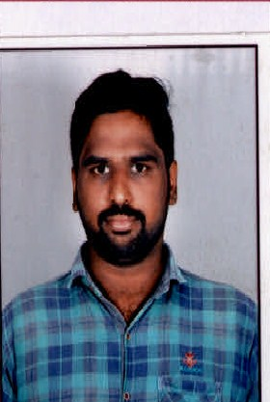



KAMIDI RAVI TEJA Analyst/Software Engineer

**Education and certificates** Bachelor of Technology, Electronic and communication : 2017 - 2020

Skills

|  |  |
| --- | --- |
|  |  |
| Spring | Framework, Spring boot,  Spring mvc |
| Angular | Components, Modules, Routing, |
| Java | Oops Concept |
| Database | MySQL Server |
| UI Tech | HTML 5 & CSS 3,JavaScript, |
| Tools | Git, Postman, Eclipse, visual Studio code,pg Admin |
|  |  |

**Base Location:** Mumbai

**Email ID: Mobile No:**

# [RAVI-TEJA.KAMIDI@capgemini.com](mailto:RAVI-TEJA.KAMIDI@capgemini.com)



+91 9885186136

**Grade:** A4



**Strengths Achievement**

* Hands on experience on **MySQL Server,**

**Java, Hibernate, Spring boot, Html, CSS, Angular.**

* Proficient in creating **Single page Web** Application in

Angular.

* Hands on experience in developing web pages

using HTML5, CSS3, Java script, TypeScript.

Good understanding of Document Object Model

(DOM) and DOM Functions.

* Currently completing the Course On **iTransform-**

GitHub, mongo dB, UMl, java core, Angular

* Completed Case study On **Employee Management System** Which is basically mange the addition of employee and getting employee compliances and status of the project

# 

Presentation Title | Author | Date © Capgemini 2017. All rights reserved | 1